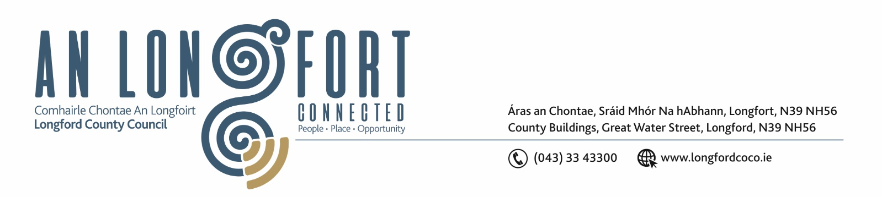
9 November 2022

Chuig: Gach Ball don Chomhairle.

A Chomhairleoir,

You are requested to attend the Statutory Local Authority Budget Meeting of Longford County Council to be held in Council Chamber, Aras an Chontae, Longford and via Microsoft Teams on Monday 21 November 2022 at 4pm to transact business as set out on the agenda hereunder.

Mise le meas,

Ann Marie Mc Keon
________________
Ann Marie Mc Keon,
Meetings Administrator.

C L Á R

Prayer before meeting.

- Consideration of 2023 Draft Budget.



